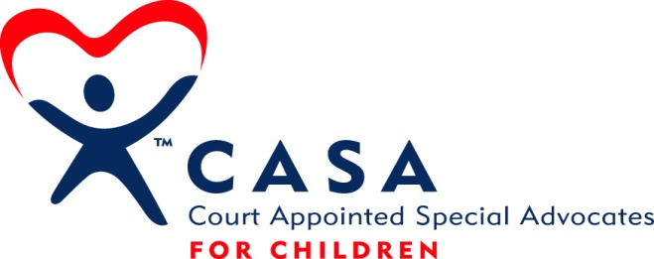

Anti-Discrimination Policy and Equal Employment Opportunity Policy

Anti-Discrimination
CASA for York County does not discriminate on the basis of race, sex, ethnicity, age, religion, national origin, color, weight, height, marital status, veteran status, disability, or sexual orientation in its service to children and their families or with regard to volunteer recruitment, training, case assignment, or other activities, or in regard to its employment practices. This prohibition includes sexual harassment consisting of unwelcome sexual advances, requests for sexual favors, or other verbal or physical conduct of a sexual nature. CASA for York County will take disciplinary steps against any employee who engages in such behavior.

Any employee who believes that he or she has been subjected to such harassment must report that fact immediately in writing to the Executive Director or the president of the Board of Directors. The report will be promptly investigated and action will be taken as appropriate. To the extent possible, the investigation will protect the privacy of the individuals involved. The employer will protect the employee from retaliation or any other detrimental impact on his or her employment.

Equal Employment Opportunity
CASA for York County is dedicated to the principles of equal employment opportunity. We prohibit unlawful discrimination against applicants or employees on the basis of age 40 and over, race, sex, color, religion, national origin, disability, military status, genetic information, or any other status protected by applicable state or local law.

ADA and Religious Accommodation
CASA for York County will make reasonable accommodation for qualified individuals with known disabilities unless doing so would result in an undue hardship to CASA for York County or cause a direct threat to health or safety. CASA for York County will make reasonable accommodation for employees whose work requirements interfere with a religious belief, unless doing so poses undue hardship on CASA for York County. Employees needing such accommodation are instructed to contact the CASA for York County Executive Director, or the CASA for York County Board President.

EEO Harassment
CASA for York County strives to maintain a work environment free of unlawful harassment. In doing so, CASA for York County prohibits unlawful harassment because of age 40 and over, race, sex, color, religion, national origin, disability, military status, genetic information, or any other status protected by applicable state or local law.

Unlawful harassment includes verbal or physical conduct that has the purpose or effect of substantially interfering with an individual’s work performance or creating an intimidating, hostile, or offensive work environment. Actions based on an individual’s age 40 and over, race, sex, color, religion, national origin, disability, military status, genetic information, or any other applicable status protected by state or local law will not be tolerated. Prohibited behavior may include but is not limited to the following:

- Written form such as cartoons, e-mails, posters, drawings, or photographs.
- Verbal conduct such as epithets, derogatory comments, slurs, or jokes.
- Physical conduct such as assault, or blocking an individual’s movements.

This policy applies to all employees including managers, supervisors, co-workers, and non-employees, including volunteers.

Sexual Harassment
Because sexual harassment raises issues that are to some extent unique in comparison to other types of harassment, CASA for York County believes it warrants separate emphasis.

CASA for York County strongly opposes sexual harassment and inappropriate sexual conduct. Sexual harassment is defined as unwelcome sexual advances, requests for sexual favors, and other verbal or physical conduct of a sexual nature, when:

- Submission to such conduct is made explicitly or implicitly a term or condition of employment.
- Submission to or rejection of such conduct is used as the basis for decisions affecting an individual’s employment.
- Such conduct has the purpose or effect of substantially interfering with an individual’s work performance or creating an intimidating, hostile, or offensive work environment.

All employees are expected to conduct themselves in a professional and businesslike manner at all times. Conduct which may violate this policy includes, but is not limited to, sexually implicit or explicit communications whether in:

- Written form, such as cartoons, posters, calendars, notes, letters, e-mails.
- Verbal form, such as comments, jokes, foul or obscene language of a sexual nature, gossiping or questions about another’s sex life, or repeated unwanted requests for dates.
- Physical gestures and other nonverbal behavior, such as unwelcome touching, grabbing, fondling, kissing, massaging, and brushing up against another’s body.

Complaint Procedure
If you believe there has been a violation of the EEO policy or harassment based on a protected class, including sexual harassment, please use the following complaint procedure. CASA for York County expects employees to make a timely complaint to enable CASA for York County to investigate and correct any behavior that may be in violation of this policy.

Report the incident to Executive Director or Board President, who will investigate the matter and take corrective action. Your complaint will be kept as confidential as practicable. If you prefer not to go to either of these individuals with your complaint, you should report the incident to another CASA for York County Board Member or the Nebraska Crime Commission at 402-471-2194.

CASA for York County prohibits retaliation against an employee for filing a complaint under this policy or for assisting in a complaint investigation. If you perceive retaliation for making a complaint or your participation in the investigation, please follow the complaint procedure outlined above. The situation will be investigated.

If CASA for York County determines that an employee’s behavior is in violation of this policy, disciplinary action will be taken, up to and including termination of employment.

