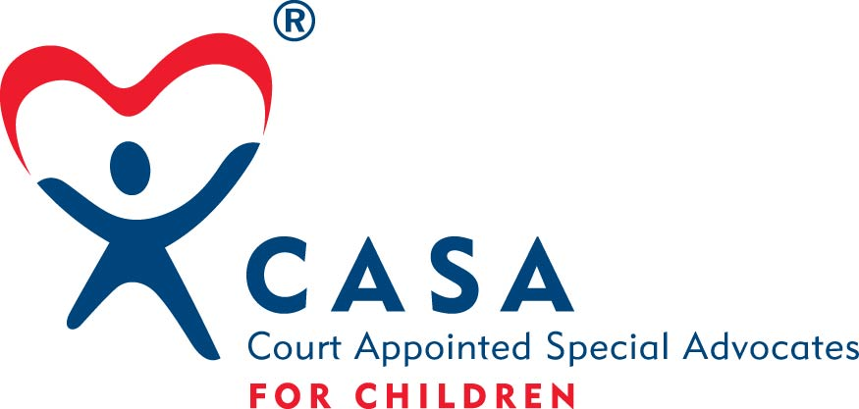 CASA for York County
Electronic & Social Media Policy

Volunteers, staff, and Board Members with CASA for York County shall refrain from posting any inappropriate material, providing links to inappropriate websites, posting undesirable comments, references or pictures anywhere on the web where the posting directly or indirectly refers to CASA for York County or any pseudonym that is meant to refer to CASA for York County, or to any individual associated with CASA for York County. Anyone found to be in violation of this policy may be sanctioned at the discretion of CASA for York County Executive Director or Board of Directors. This policy includes public postings to any electronic media including email.

“Inappropriate material” shall be defined as postings, depictions or descriptions of illicit substances and/or their paraphernalia, underage drinking, inclusion of harassing, hostile, false, or confidential information, and any other acts that violate CASA for York County, local, state, federal laws, statutes, rules, and regulations. Also prohibited are prejudiced or discriminatory statements against any individuals, businesses, government agencies or groups.

Volunteers, staff, and Board Members with CASA for York County shall avoid creating the impression that the views expressed through any electronic or social media outlet represent the views of CASA for York County unless they have cleared the electronic communication with the Executive Director of CASA for York County.
Volunteers, staff, and Board Members with CASA for York County shall avoid engaging in arguments or debates regarding anything connected to or referring to CASA for York County when using electronic media. If you are in doubt refer to the code of ethics for CASA for York County or contact the Executive Director of CASA for York County.

Postings which directly or indirectly make reference to CASA for York County include, but are not limited to, postings which name CASA, the Court Appointed Special Advocate Program or any name meant to refer to the organization, photographs or videos which depict the CASA name, logo, or symbols, photographs or videos which display any CASA for York County sponsored activities, postings which link to any local, state, national, International web page referring to CASA, and user names or email addresses which indicate an affiliation with the CASA for York County Program.

I have read, understand and will abide by the CASA for York County Electronic and Social Media Policy.

_________________________________________ ______________________________
CASA Volunteer/Staff/Board Member Date

_________________________________________ ______________________________
CASA Executive Director Date

Approved 5/2015

