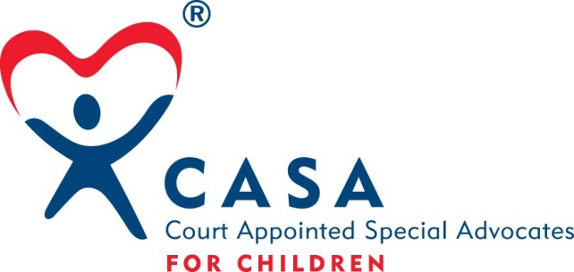

Whistleblower Policy
For
CASA for York County

A whistleblower as defined by this policy is an employee, board member or volunteer of CASA for York County who reports any activity that he/she considers to be illegal, dishonest, unethical or inappropriate. The whistleblower is not responsible for investigating the activity or for determining fault or corrective measures.

The whistleblower shall report the alleged wrongdoing to the Executive Director or Board President. An employee who intentionally files a false report of wrongdoing will be subject to discipline up to and including termination.

Whistleblower protections are provided in two important areas: providing confidentiality and preventing retaliation. Insofar as possible, the confidentiality of the whistleblower will be maintained. However, identity may have to be disclosed to conduct a thorough investigation, to comply with the law and to provide accused individuals their legal rights of defense. CASA for York County will not retaliate against a whistleblower. This includes, but is not limited to, protection from retaliation in the form of adverse employment actions such as termination, compensation decreases, poor work assignments and threats of physical harm. Any whistleblower who believes he/she is being retaliated against may contact any member of the Executive Committee (President, Vice-President, Secretary, Treasurer). The right of a whistleblower for protection against retaliation does not include immunity for any personal wrongdoing that is alleged and investigated.

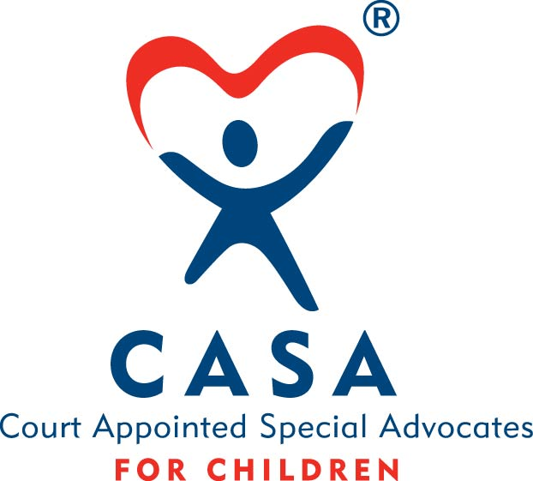

CASA for York County
Whistleblower Accountability Statement

I certify that:

- I have read and understand the CASA for York County Whistleblower policy.

- I will report any conduct which I believe to be illegal, dishonest, or unethical to the Executive Director or Board President.

- Any whistleblower who believes he/she is being retaliated against may contact any member of the Executive Committee (President, Vice-President, Secretary, and Treasurer).

_________________________________ ___________________________
Board/Staff/Volunteer Member Date

CASA for York County
510 N Lincoln Ave.
York, NE 68467
# (402) 362-5454

“CASA for York County supports and provides volunteer advocacy for abused and neglected children, enabling them to thrive in a safe, permanent home.”

Approved 4/14/10

