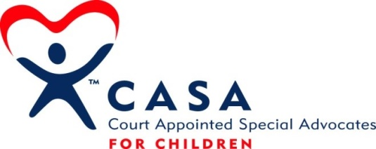

CASA for York County
FINANCIAL RESOURCES PLAN

1. Budget
- The executive director and board treasurer will conduct an annual review of expenses and revenue trends and propose a budget for the upcoming year.
- Proposed budget reviewed and approved by board at annual meeting.
- Monthly budget monitoring, led by board treasurer, used as a review, evaluation and forecast tool.
- Strict adherence to budget mandated minimum of 50% of annual budget as cash in-hand or cash equivalents at all times.

2. Projected Revenue Sources
- York County funding.
- Foundation grants.
- State CASA funding.
- Corporate and business gifts.
- Board and leadership donations.
- Direct appeal fundraising audiences.
- Government grants.

3. Revenue Generating Activities
- Annual funding request submitted to the York County Commissioners and ongoing reporting protocols to keep commissioners informed.
- Regular grant requests submitted to foundations, United Way and other entities as appropriate with follow up reporting as required by grant-making entity.
- Event fundraising designed to also engage and inform.
- Leadership gift appeals (Friends of CASA program).
- Direct fundraising appeals.
- Bi-annual newsletter that includes a reply envelope for recipients to respond with donations.
- Responsive, prompt gift processing and appropriate donor recognition and stewardship.

4. Asset Management
- Cash or cash equivalents.
- Short-term certificates or other instruments will be used to hold funds above a board-mandated minimum.
- Ongoing management of donor and general constituency database.
- Testamentary bequest or other estate gift in excess of $500,000 will be invested as deemed appropriate as designated by the benefactor with a local trust department or financial planner charged with management of the fund, subject to review by the CASA for York County board. Planned gifts of less than the $500,000 threshold shall be evaluated by the board.
- Planned gifts received that are less than $50,000 shall be added to the program’s general fund.

5. Personnel Engagement in Components of the Financial Resources Plan
- Professional staff will manage direct fundraising appeals, bi-annual newsletter, gift receipting and constituency database management.
- Professional staff in collaboration with assigned board members will manage grant requests and leadership gift appeals.
- Assigned board members will lead event fundraising activities, implemented in collaboration with professional staff.
- Board will oversee budgeting processes and cash management activities, working alongside executive director.

6. Financial Transparency
- External audit or other reviews will be conducted in compliance with National CASA standards and in compliance with local program guidelines.
- CASA for York County endorses and adheres to the guidelines found in the Donor Bill of Rights (Financial Resources Plan Appendix One)

